C:\Users\jxbailey\AppData\Local\Microsoft\Windows\Temporary Internet Files\Content.IE5\6YLPD4KX\MC900410769[1].wmfC:\Users\jxbailey\AppData\Local\Microsoft\Windows\Temporary Internet Files\Content.IE5\6YLPD4KX\MC900410769[1].wmfDecember Calendar Math

|  |  |  |  |  |  |  |  |  |  |  |  |  |  |  |  |  |  |  |  |
| --- | --- | --- | --- | --- | --- | --- | --- | --- | --- | --- | --- | --- | --- | --- | --- | --- | --- | --- | --- |
| **Date** | | **Day of School** | | **Date** | | **Day of School** | | **Date** | | **Day of School** | | **Date** | | **Day of School** | | **Date** | | **Day of School** | |
| **F** | **D** | | **P** | **F** | **D** | | **P** | **F** | **D** | | **P** | **F** | **D** | | **P** | **F** | **D** | | **P** |
|  | | | |  | | | |  | | | |  | | | |  | | | |
| **Daily Variable**:  100d+(12) =________ | | | | **Daily Variable**:  100d+(12) =________ | | | | **Daily Variable**:  100d+(12) =________ | | | | **Daily Variable**:  100d+(12) =________ | | | | **Daily Variable**:  100d+(12) =________ | | | |
| **Daily Depositor**  1% of (date●100)  C:\Users\jxbailey\AppData\Local\Microsoft\Windows\Temporary Internet Files\Content.IE5\6YLPD4KX\MC900325596[1].wmfC:\Users\jxbailey\AppData\Local\Microsoft\Windows\Temporary Internet Files\Content.IE5\6YLPD4KX\MC900325596[1].wmfDeposit Total | | | | **Daily Depositor**  1% of (date●100)  C:\Users\jxbailey\AppData\Local\Microsoft\Windows\Temporary Internet Files\Content.IE5\6YLPD4KX\MC900325596[1].wmfC:\Users\jxbailey\AppData\Local\Microsoft\Windows\Temporary Internet Files\Content.IE5\6YLPD4KX\MC900325596[1].wmfDeposit Total | | | | **Daily Depositor**  1% of (date●100)  C:\Users\jxbailey\AppData\Local\Microsoft\Windows\Temporary Internet Files\Content.IE5\6YLPD4KX\MC900325596[1].wmfC:\Users\jxbailey\AppData\Local\Microsoft\Windows\Temporary Internet Files\Content.IE5\6YLPD4KX\MC900325596[1].wmfDeposit Total | | | | **Daily Depositor**  1% of (date●100)  C:\Users\jxbailey\AppData\Local\Microsoft\Windows\Temporary Internet Files\Content.IE5\6YLPD4KX\MC900325596[1].wmfC:\Users\jxbailey\AppData\Local\Microsoft\Windows\Temporary Internet Files\Content.IE5\6YLPD4KX\MC900325596[1].wmfDeposit Total | | | | **Daily Depositor**  1% of (date●100)  C:\Users\jxbailey\AppData\Local\Microsoft\Windows\Temporary Internet Files\Content.IE5\6YLPD4KX\MC900325596[1].wmfC:\Users\jxbailey\AppData\Local\Microsoft\Windows\Temporary Internet Files\Content.IE5\6YLPD4KX\MC900325596[1].wmfDeposit Total | | | |
| **Daily Pattern:**  Oranges:______  Total Oranges:______ | | | | **Daily Pattern:**  Oranges:______  Total Oranges:______ | | | | **Daily Pattern:**  Oranges:______  Total Oranges:______ | | | | **Daily Pattern:**  Oranges:______  Total Oranges:______ | | | | **Daily Pattern:**  Oranges:______  Total Oranges:______ | | | |
| **Date** | | **Day of School** | | **Date** | | **Day of School** | | **Date** | | **Day of School** | | **Date** | | **Day of School** | | **Date** | | **Day of School** | |
| **F** | **D** | | **P** | **F** | **D** | | **P** | **F** | **D** | | **P** | **F** | **D** | | **P** | **F** | **D** | | **P** |
|  | | | |  | | | |  | | | |  | | | |  | | | |
| **Daily Variable**:  100d+(12) =________ | | | | **Daily Variable**:  100d+(12) =________ | | | | **Daily Variable**:  100d+(12) =________ | | | | **Daily Variable**:  100d+(12) =________ | | | | **Daily Variable**:  100d+(12) =________ | | | |
| **Daily Depositor**  1% of (date●100)  C:\Users\jxbailey\AppData\Local\Microsoft\Windows\Temporary Internet Files\Content.IE5\6YLPD4KX\MC900325596[1].wmfC:\Users\jxbailey\AppData\Local\Microsoft\Windows\Temporary Internet Files\Content.IE5\6YLPD4KX\MC900325596[1].wmfDeposit Total | | | | **Daily Depositor**  1% of (date●100)  C:\Users\jxbailey\AppData\Local\Microsoft\Windows\Temporary Internet Files\Content.IE5\6YLPD4KX\MC900325596[1].wmfC:\Users\jxbailey\AppData\Local\Microsoft\Windows\Temporary Internet Files\Content.IE5\6YLPD4KX\MC900325596[1].wmfDeposit Total | | | | **Daily Depositor**  1% of (date●100)  C:\Users\jxbailey\AppData\Local\Microsoft\Windows\Temporary Internet Files\Content.IE5\6YLPD4KX\MC900325596[1].wmfC:\Users\jxbailey\AppData\Local\Microsoft\Windows\Temporary Internet Files\Content.IE5\6YLPD4KX\MC900325596[1].wmfDeposit Total | | | | **Daily Depositor**  1% of (date●100)  C:\Users\jxbailey\AppData\Local\Microsoft\Windows\Temporary Internet Files\Content.IE5\6YLPD4KX\MC900325596[1].wmfC:\Users\jxbailey\AppData\Local\Microsoft\Windows\Temporary Internet Files\Content.IE5\6YLPD4KX\MC900325596[1].wmfDeposit Total | | | | **Daily Depositor**  1% of (date●100)  C:\Users\jxbailey\AppData\Local\Microsoft\Windows\Temporary Internet Files\Content.IE5\6YLPD4KX\MC900325596[1].wmfC:\Users\jxbailey\AppData\Local\Microsoft\Windows\Temporary Internet Files\Content.IE5\6YLPD4KX\MC900325596[1].wmfDeposit Total | | | |
| **Daily Pattern:**  Oranges:______  Total Oranges:______ | | | | **Daily Pattern:**  Oranges:______  Total Oranges:______ | | | | **Daily Pattern:**  Oranges:______  Total Oranges:______ | | | | **Daily Pattern:**  Oranges:______  Total Oranges:______ | | | | **Daily Pattern:**  Oranges:______  Total Oranges:______ | | | |

|  |  |  |  |  |  |  |  |  |  |  |  |  |  |  |  |  |  |  |  |
| --- | --- | --- | --- | --- | --- | --- | --- | --- | --- | --- | --- | --- | --- | --- | --- | --- | --- | --- | --- |
| **Date** | | **Day of School** | | **Date** | | **Day of School** | | **Date** | | **Day of School** | | **Date** | | **Day of School** | | **Date** | | **Day of School** | |
| **F** | **D** | | **P** | **F** | **D** | | **P** | **F** | **D** | | **P** | **F** | **D** | | **P** | **F** | **D** | | **P** |
|  | | | |  | | | |  | | | |  | | | |  | | | |
| **Daily Variable**:  100d+(12) =________ | | | | **Daily Variable**:  100d+(12) =________ | | | | **Daily Variable**:  100d+(12) =________ | | | | **Daily Variable**:  100d+(12) =________ | | | | **Daily Variable**:  100d+(12) =________ | | | |
| **Daily Depositor**  1% of (date●100)  C:\Users\jxbailey\AppData\Local\Microsoft\Windows\Temporary Internet Files\Content.IE5\6YLPD4KX\MC900325596[1].wmfC:\Users\jxbailey\AppData\Local\Microsoft\Windows\Temporary Internet Files\Content.IE5\6YLPD4KX\MC900325596[1].wmfDeposit Total | | | | **Daily Depositor**  1% of (date●100)  C:\Users\jxbailey\AppData\Local\Microsoft\Windows\Temporary Internet Files\Content.IE5\6YLPD4KX\MC900325596[1].wmfC:\Users\jxbailey\AppData\Local\Microsoft\Windows\Temporary Internet Files\Content.IE5\6YLPD4KX\MC900325596[1].wmfDeposit Total | | | | **Daily Depositor**  1% of (date●100)  C:\Users\jxbailey\AppData\Local\Microsoft\Windows\Temporary Internet Files\Content.IE5\6YLPD4KX\MC900325596[1].wmfC:\Users\jxbailey\AppData\Local\Microsoft\Windows\Temporary Internet Files\Content.IE5\6YLPD4KX\MC900325596[1].wmfDeposit Total | | | | **Daily Depositor**  1% of (date●100)  C:\Users\jxbailey\AppData\Local\Microsoft\Windows\Temporary Internet Files\Content.IE5\6YLPD4KX\MC900325596[1].wmfC:\Users\jxbailey\AppData\Local\Microsoft\Windows\Temporary Internet Files\Content.IE5\6YLPD4KX\MC900325596[1].wmfDeposit Total | | | | **Daily Depositor**  1% of (date●100)  C:\Users\jxbailey\AppData\Local\Microsoft\Windows\Temporary Internet Files\Content.IE5\6YLPD4KX\MC900325596[1].wmfC:\Users\jxbailey\AppData\Local\Microsoft\Windows\Temporary Internet Files\Content.IE5\6YLPD4KX\MC900325596[1].wmfDeposit Total | | | |
| **Daily Pattern:**  Oranges:______  Total Oranges:______ | | | | **Daily Pattern:**  Oranges:______  Total Oranges:______ | | | | **Daily Pattern:**  Oranges:______  Total Oranges:______ | | | | **Daily Pattern:**  Oranges:______  Total Oranges:______ | | | | **Daily Pattern:**  Oranges:______  Total Oranges:______ | | | |

|  |  |  |  |  |  |  |  |  |  |  |  |  |  |  |  |  |  |  |  |
| --- | --- | --- | --- | --- | --- | --- | --- | --- | --- | --- | --- | --- | --- | --- | --- | --- | --- | --- | --- |
| **Date** | | **Day of School** | | **Date** | | **Day of School** | | **Date** | | **Day of School** | | **Date** | | **Day of School** | | **Date** | | **Day of School** | |
| **F** | **D** | | **P** | **F** | **D** | | **P** | **F** | **D** | | **P** | **F** | **D** | | **P** | **F** | **D** | | **P** |
|  | | | |  | | | |  | | | |  | | | |  | | | |
| **Daily Variable**:  100d+(12) =________ | | | | **Daily Variable**:  100d+(12) =________ | | | | **Daily Variable**:  100d+(12) =________ | | | | **Daily Variable**:  100d+(12) =________ | | | | **Daily Variable**:  100d+(12) =________ | | | |
| **Daily Depositor**  1% of (date●100)  C:\Users\jxbailey\AppData\Local\Microsoft\Windows\Temporary Internet Files\Content.IE5\6YLPD4KX\MC900325596[1].wmfC:\Users\jxbailey\AppData\Local\Microsoft\Windows\Temporary Internet Files\Content.IE5\6YLPD4KX\MC900325596[1].wmfDeposit Total | | | | **Daily Depositor**  1% of (date●100)  C:\Users\jxbailey\AppData\Local\Microsoft\Windows\Temporary Internet Files\Content.IE5\6YLPD4KX\MC900325596[1].wmfC:\Users\jxbailey\AppData\Local\Microsoft\Windows\Temporary Internet Files\Content.IE5\6YLPD4KX\MC900325596[1].wmfDeposit Total | | | | **Daily Depositor**  1% of (date●100)  C:\Users\jxbailey\AppData\Local\Microsoft\Windows\Temporary Internet Files\Content.IE5\6YLPD4KX\MC900325596[1].wmfC:\Users\jxbailey\AppData\Local\Microsoft\Windows\Temporary Internet Files\Content.IE5\6YLPD4KX\MC900325596[1].wmfDeposit Total | | | | **Daily Depositor**  1% of (date●100)  C:\Users\jxbailey\AppData\Local\Microsoft\Windows\Temporary Internet Files\Content.IE5\6YLPD4KX\MC900325596[1].wmfC:\Users\jxbailey\AppData\Local\Microsoft\Windows\Temporary Internet Files\Content.IE5\6YLPD4KX\MC900325596[1].wmfDeposit Total | | | | **Daily Depositor**  1% of (date●100)  C:\Users\jxbailey\AppData\Local\Microsoft\Windows\Temporary Internet Files\Content.IE5\6YLPD4KX\MC900325596[1].wmfC:\Users\jxbailey\AppData\Local\Microsoft\Windows\Temporary Internet Files\Content.IE5\6YLPD4KX\MC900325596[1].wmfDeposit Total | | | |
| **Daily Pattern:**  Oranges:______  Total Oranges:______ | | | | **Daily Pattern:**  Oranges:______  Total Oranges:______ | | | | **Daily Pattern:**  Oranges:______  Total Oranges:______ | | | | **Daily Pattern:**  Oranges:______  Total Oranges:______ | | | | **Daily Pattern:**  Oranges:______  Total Oranges:______ | | | |

|  |  |  |  |  |  |  |  |  |  |  |  |  |  |  |  |  |  |  |  |
| --- | --- | --- | --- | --- | --- | --- | --- | --- | --- | --- | --- | --- | --- | --- | --- | --- | --- | --- | --- |
| **Date** | | **Day of School** | | **Date** | | **Day of School** | | **Date** | | **Day of School** | | **Date** | | **Day of School** | | **Date** | | **Day of School** | |
| **F** | **D** | | **P** | **F** | **D** | | **P** | **F** | **D** | | **P** | **F** | **D** | | **P** | **F** | **D** | | **P** |
|  | | | |  | | | |  | | | |  | | | |  | | | |
| **Daily Variable**:  100d+(12) =________ | | | | **Daily Variable**:  100d+(12) =________ | | | | **Daily Variable**:  100d+(12) =________ | | | | **Daily Variable**:  100d+(12) =________ | | | | **Daily Variable**:  100d+(12) =________ | | | |
| **Daily Depositor**  1% of (date●100)  C:\Users\jxbailey\AppData\Local\Microsoft\Windows\Temporary Internet Files\Content.IE5\6YLPD4KX\MC900325596[1].wmfC:\Users\jxbailey\AppData\Local\Microsoft\Windows\Temporary Internet Files\Content.IE5\6YLPD4KX\MC900325596[1].wmfDeposit Total | | | | **Daily Depositor**  1% of (date●100)  C:\Users\jxbailey\AppData\Local\Microsoft\Windows\Temporary Internet Files\Content.IE5\6YLPD4KX\MC900325596[1].wmfC:\Users\jxbailey\AppData\Local\Microsoft\Windows\Temporary Internet Files\Content.IE5\6YLPD4KX\MC900325596[1].wmfDeposit Total | | | | **Daily Depositor**  1% of (date●100)  C:\Users\jxbailey\AppData\Local\Microsoft\Windows\Temporary Internet Files\Content.IE5\6YLPD4KX\MC900325596[1].wmfC:\Users\jxbailey\AppData\Local\Microsoft\Windows\Temporary Internet Files\Content.IE5\6YLPD4KX\MC900325596[1].wmfDeposit Total | | | | **Daily Depositor**  1% of (date●100)  C:\Users\jxbailey\AppData\Local\Microsoft\Windows\Temporary Internet Files\Content.IE5\6YLPD4KX\MC900325596[1].wmfC:\Users\jxbailey\AppData\Local\Microsoft\Windows\Temporary Internet Files\Content.IE5\6YLPD4KX\MC900325596[1].wmfDeposit Total | | | | **Daily Depositor**  1% of (date●100)  C:\Users\jxbailey\AppData\Local\Microsoft\Windows\Temporary Internet Files\Content.IE5\6YLPD4KX\MC900325596[1].wmfC:\Users\jxbailey\AppData\Local\Microsoft\Windows\Temporary Internet Files\Content.IE5\6YLPD4KX\MC900325596[1].wmfDeposit Total | | | |
| **Daily Pattern:**  Oranges:______  Total Oranges:______ | | | | **Daily Pattern:**  Oranges:______  Total Oranges:______ | | | | **Daily Pattern:**  Oranges:______  Total Oranges:______ | | | | **Daily Pattern:**  Oranges:______  Total Oranges:______ | | | | **Daily Pattern:**  Oranges:______  Total Oranges:______ | | | |

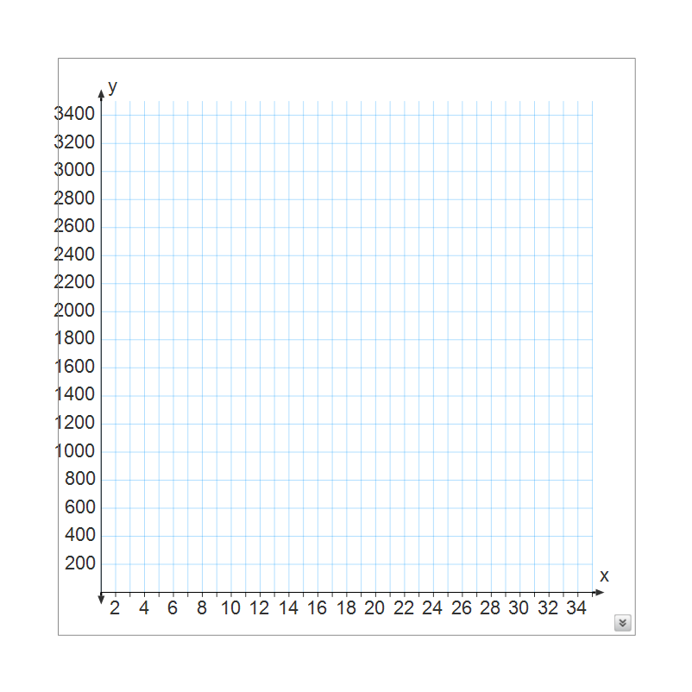 **Percent Circle: Daily Variable Graph**



** Arrays:**

**Daily Pattern**

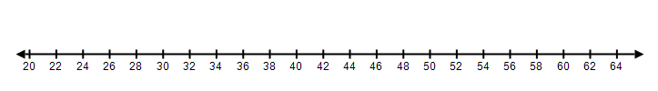

Degrees Fahrenheit

**Daily Data**

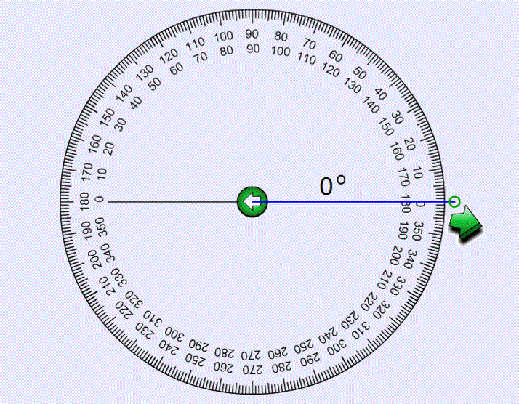 **Daily Circle**