January Calendar Math

|  |  |  |  |  |  |  |  |  |  |  |  |  |  |  |  |  |  |  |  |
| --- | --- | --- | --- | --- | --- | --- | --- | --- | --- | --- | --- | --- | --- | --- | --- | --- | --- | --- | --- |
| **Date** | | **Day of School** | | **Date** | | **Day of School** | | **Date** | | **Day of School** | | **Date** | | **Day of School** | | **Date** | | **Day of School** | |
| **F** | **D** | | **P** | **F** | **D** | | **P** | **F** | **D** | | **P** | **F** | **D** | | **P** | **F** | **D** | | **P** |
| Daily Data:  Today’s Temperature:  _________ | | | | Daily Data:  Today’s Temperature:  _________ | | | | Daily Data:  Today’s Temperature:  _________ | | | | Daily Data:  Today’s Temperature:  _________ | | | | Daily Data:  Today’s Temperature:  _________ | | | |
| **Daily Variable**:  d2 =________ | | | | **Daily Variable**:  d2 =________ | | | | **Daily Variable**:  d2 =________ | | | | **Daily Variable**:  d2 =________ | | | | **Daily Variable**:  d2 =________ | | | |
| **Daily Depositor**  110% of (date●100)  C:\Users\jxbailey\AppData\Local\Microsoft\Windows\Temporary Internet Files\Content.IE5\6YLPD4KX\MC900325596[1].wmfC:\Users\jxbailey\AppData\Local\Microsoft\Windows\Temporary Internet Files\Content.IE5\6YLPD4KX\MC900325596[1].wmfDeposit Total | | | | **Daily Depositor**  110% of (date●100)  C:\Users\jxbailey\AppData\Local\Microsoft\Windows\Temporary Internet Files\Content.IE5\6YLPD4KX\MC900325596[1].wmfC:\Users\jxbailey\AppData\Local\Microsoft\Windows\Temporary Internet Files\Content.IE5\6YLPD4KX\MC900325596[1].wmfDeposit Total | | | | **Daily Depositor**  110% of (date●100)  C:\Users\jxbailey\AppData\Local\Microsoft\Windows\Temporary Internet Files\Content.IE5\6YLPD4KX\MC900325596[1].wmfC:\Users\jxbailey\AppData\Local\Microsoft\Windows\Temporary Internet Files\Content.IE5\6YLPD4KX\MC900325596[1].wmfDeposit Total | | | | **Daily Depositor**  110% of (date●100)  C:\Users\jxbailey\AppData\Local\Microsoft\Windows\Temporary Internet Files\Content.IE5\6YLPD4KX\MC900325596[1].wmfC:\Users\jxbailey\AppData\Local\Microsoft\Windows\Temporary Internet Files\Content.IE5\6YLPD4KX\MC900325596[1].wmfDeposit Total | | | | **Daily Depositor**  110% of (date●100)  C:\Users\jxbailey\AppData\Local\Microsoft\Windows\Temporary Internet Files\Content.IE5\6YLPD4KX\MC900325596[1].wmfC:\Users\jxbailey\AppData\Local\Microsoft\Windows\Temporary Internet Files\Content.IE5\6YLPD4KX\MC900325596[1].wmfDeposit Total | | | |
| **Daily Pattern:**  Length of sides:______  Area: __________ | | | | **Daily Pattern:**  Length of sides:______  Area: __________ | | | | **Daily Pattern:**  Length of sides:______  Area: __________ | | | | **Daily Pattern:**  Length of sides:______  Area: __________ | | | | **Daily Pattern:**  Length of sides:______  Area: __________ | | | |
| **Date** | | **Day of School** | | **Date** | | **Day of School** | | **Date** | | **Day of School** | | **Date** | | **Day of School** | | **Date** | | **Day of School** | |
| **F** | **D** | | **P** | **F** | **D** | | **P** | **F** | **D** | | **P** | **F** | **D** | | **P** | **F** | **D** | | **P** |
| Daily Data:  Today’s Temperature:  _________ | | | | Daily Data:  Today’s Temperature:  _________ | | | | Daily Data:  Today’s Temperature:  _________ | | | | Daily Data:  Today’s Temperature:  _________ | | | | Daily Data:  Today’s Temperature:  _________ | | | |
| **Daily Variable**:  d2 =________ | | | | **Daily Variable**:  d2 =________ | | | | **Daily Variable**:  d2 =________ | | | | **Daily Variable**:  d2 =________ | | | | **Daily Variable**:  d2 =________ | | | |
| **Daily Depositor**  110% of (date●100)  C:\Users\jxbailey\AppData\Local\Microsoft\Windows\Temporary Internet Files\Content.IE5\6YLPD4KX\MC900325596[1].wmfC:\Users\jxbailey\AppData\Local\Microsoft\Windows\Temporary Internet Files\Content.IE5\6YLPD4KX\MC900325596[1].wmfDeposit Total | | | | **Daily Depositor**  110% of (date●100)  C:\Users\jxbailey\AppData\Local\Microsoft\Windows\Temporary Internet Files\Content.IE5\6YLPD4KX\MC900325596[1].wmfC:\Users\jxbailey\AppData\Local\Microsoft\Windows\Temporary Internet Files\Content.IE5\6YLPD4KX\MC900325596[1].wmfDeposit Total | | | | **Daily Depositor**  110% of (date●100)  C:\Users\jxbailey\AppData\Local\Microsoft\Windows\Temporary Internet Files\Content.IE5\6YLPD4KX\MC900325596[1].wmfC:\Users\jxbailey\AppData\Local\Microsoft\Windows\Temporary Internet Files\Content.IE5\6YLPD4KX\MC900325596[1].wmfDeposit Total | | | | **Daily Depositor**  110% of (date●100)  C:\Users\jxbailey\AppData\Local\Microsoft\Windows\Temporary Internet Files\Content.IE5\6YLPD4KX\MC900325596[1].wmfC:\Users\jxbailey\AppData\Local\Microsoft\Windows\Temporary Internet Files\Content.IE5\6YLPD4KX\MC900325596[1].wmfDeposit Total | | | | **Daily Depositor**  110% of (date●100)  C:\Users\jxbailey\AppData\Local\Microsoft\Windows\Temporary Internet Files\Content.IE5\6YLPD4KX\MC900325596[1].wmfC:\Users\jxbailey\AppData\Local\Microsoft\Windows\Temporary Internet Files\Content.IE5\6YLPD4KX\MC900325596[1].wmfDeposit Total | | | |
| **Daily Pattern:**  Length of sides:______  Area: __________ | | | | **Daily Pattern:**  Length of sides:______  Area: __________ | | | | **Daily Pattern:**  Length of sides:______  Area: __________ | | | | **Daily Pattern:**  Length of sides:______  Area: __________ | | | | **Daily Pattern:**  Length of sides:______  Area: __________ | | | |

|  |  |  |  |  |  |  |  |  |  |  |  |  |  |  |  |  |  |  |  |
| --- | --- | --- | --- | --- | --- | --- | --- | --- | --- | --- | --- | --- | --- | --- | --- | --- | --- | --- | --- |
| **Date** | | **Day of School** | | **Date** | | **Day of School** | | **Date** | | **Day of School** | | **Date** | | **Day of School** | | **Date** | | **Day of School** | |
| **F** | **D** | | **P** | **F** | **D** | | **P** | **F** | **D** | | **P** | **F** | **D** | | **P** | **F** | **D** | | **P** |
| Daily Data:  Today’s Temperature:  _________ | | | | Daily Data:  Today’s Temperature:  _________ | | | | Daily Data:  Today’s Temperature:  _________ | | | | Daily Data:  Today’s Temperature:  _________ | | | | Daily Data:  Today’s Temperature:  _________ | | | |
| **Daily Variable**:  d2 =________ | | | | **Daily Variable**:  d2 =________ | | | | **Daily Variable**:  d2 =________ | | | | **Daily Variable**:  d2 =________ | | | | **Daily Variable**:  d2 =________ | | | |
| **Daily Depositor**  110% of (date●100)  C:\Users\jxbailey\AppData\Local\Microsoft\Windows\Temporary Internet Files\Content.IE5\6YLPD4KX\MC900325596[1].wmfC:\Users\jxbailey\AppData\Local\Microsoft\Windows\Temporary Internet Files\Content.IE5\6YLPD4KX\MC900325596[1].wmfDeposit Total | | | | **Daily Depositor**  110% of (date●100)  C:\Users\jxbailey\AppData\Local\Microsoft\Windows\Temporary Internet Files\Content.IE5\6YLPD4KX\MC900325596[1].wmfC:\Users\jxbailey\AppData\Local\Microsoft\Windows\Temporary Internet Files\Content.IE5\6YLPD4KX\MC900325596[1].wmfDeposit Total | | | | **Daily Depositor**  110% of (date●100)  C:\Users\jxbailey\AppData\Local\Microsoft\Windows\Temporary Internet Files\Content.IE5\6YLPD4KX\MC900325596[1].wmfC:\Users\jxbailey\AppData\Local\Microsoft\Windows\Temporary Internet Files\Content.IE5\6YLPD4KX\MC900325596[1].wmfDeposit Total | | | | **Daily Depositor**  110% of (date●100)  C:\Users\jxbailey\AppData\Local\Microsoft\Windows\Temporary Internet Files\Content.IE5\6YLPD4KX\MC900325596[1].wmfC:\Users\jxbailey\AppData\Local\Microsoft\Windows\Temporary Internet Files\Content.IE5\6YLPD4KX\MC900325596[1].wmfDeposit Total | | | | **Daily Depositor**  110% of (date●100)  C:\Users\jxbailey\AppData\Local\Microsoft\Windows\Temporary Internet Files\Content.IE5\6YLPD4KX\MC900325596[1].wmfC:\Users\jxbailey\AppData\Local\Microsoft\Windows\Temporary Internet Files\Content.IE5\6YLPD4KX\MC900325596[1].wmfDeposit Total | | | |
| **Daily Pattern:**  Length of sides:______  Area: __________ | | | | **Daily Pattern:**  Length of sides:______  Area: __________ | | | | **Daily Pattern:**  Length of sides:______  Area: __________ | | | | **Daily Pattern:**  Length of sides:______  Area: __________ | | | | **Daily Pattern:**  Length of sides:______  Area: __________ | | | |

|  |  |  |  |  |  |  |  |  |  |  |  |  |  |  |  |  |  |  |  |
| --- | --- | --- | --- | --- | --- | --- | --- | --- | --- | --- | --- | --- | --- | --- | --- | --- | --- | --- | --- |
| **Date** | | **Day of School** | | **Date** | | **Day of School** | | **Date** | | **Day of School** | | **Date** | | **Day of School** | | **Date** | | **Day of School** | |
| **F** | **D** | | **P** | **F** | **D** | | **P** | **F** | **D** | | **P** | **F** | **D** | | **P** | **F** | **D** | | **P** |
| Daily Data:  Today’s Temperature:  _________ | | | | Daily Data:  Today’s Temperature:  _________ | | | | Daily Data:  Today’s Temperature:  _________ | | | | Daily Data:  Today’s Temperature:  _________ | | | | Daily Data:  Today’s Temperature:  _________ | | | |
| **Daily Variable**:  d2 =________ | | | | **Daily Variable**:  d2 =________ | | | | **Daily Variable**:  d2 =________ | | | | **Daily Variable**:  d2 =________ | | | | **Daily Variable**:  d2 =________ | | | |
| **Daily Depositor**  110% of (date●100)  C:\Users\jxbailey\AppData\Local\Microsoft\Windows\Temporary Internet Files\Content.IE5\6YLPD4KX\MC900325596[1].wmfC:\Users\jxbailey\AppData\Local\Microsoft\Windows\Temporary Internet Files\Content.IE5\6YLPD4KX\MC900325596[1].wmfDeposit Total | | | | **Daily Depositor**  110% of (date●100)  C:\Users\jxbailey\AppData\Local\Microsoft\Windows\Temporary Internet Files\Content.IE5\6YLPD4KX\MC900325596[1].wmfC:\Users\jxbailey\AppData\Local\Microsoft\Windows\Temporary Internet Files\Content.IE5\6YLPD4KX\MC900325596[1].wmfDeposit Total | | | | **Daily Depositor**  110% of (date●100)  C:\Users\jxbailey\AppData\Local\Microsoft\Windows\Temporary Internet Files\Content.IE5\6YLPD4KX\MC900325596[1].wmfC:\Users\jxbailey\AppData\Local\Microsoft\Windows\Temporary Internet Files\Content.IE5\6YLPD4KX\MC900325596[1].wmfDeposit Total | | | | **Daily Depositor**  110% of (date●100)  C:\Users\jxbailey\AppData\Local\Microsoft\Windows\Temporary Internet Files\Content.IE5\6YLPD4KX\MC900325596[1].wmfC:\Users\jxbailey\AppData\Local\Microsoft\Windows\Temporary Internet Files\Content.IE5\6YLPD4KX\MC900325596[1].wmfDeposit Total | | | | **Daily Depositor**  110% of (date●100)  C:\Users\jxbailey\AppData\Local\Microsoft\Windows\Temporary Internet Files\Content.IE5\6YLPD4KX\MC900325596[1].wmfC:\Users\jxbailey\AppData\Local\Microsoft\Windows\Temporary Internet Files\Content.IE5\6YLPD4KX\MC900325596[1].wmfDeposit Total | | | |
| **Daily Pattern:**  Length of sides:______  Area: __________ | | | | **Daily Pattern:**  Length of sides:______  Area: __________ | | | | **Daily Pattern:**  Length of sides:______  Area: __________ | | | | **Daily Pattern:**  Length of sides:______  Area: __________ | | | | **Daily Pattern:**  Length of sides:______  Area: __________ | | | |

|  |  |  |  |  |  |  |  |  |  |  |  |  |  |  |  |  |  |  |  |
| --- | --- | --- | --- | --- | --- | --- | --- | --- | --- | --- | --- | --- | --- | --- | --- | --- | --- | --- | --- |
| **Date** | | **Day of School** | | **Date** | | **Day of School** | | **Date** | | **Day of School** | | **Date** | | **Day of School** | | **Date** | | **Day of School** | |
| **F** | **D** | | **P** | **F** | **D** | | **P** | **F** | **D** | | **P** | **F** | **D** | | **P** | **F** | **D** | | **P** |
| Daily Data:  Today’s Temperature:  _________ | | | | Daily Data:  Today’s Temperature:  _________ | | | | Daily Data:  Today’s Temperature:  _________ | | | | Daily Data:  Today’s Temperature:  _________ | | | | Daily Data:  Today’s Temperature:  _________ | | | |
| **Daily Variable**:  d2 =________ | | | | **Daily Variable**:  d2 =________ | | | | **Daily Variable**:  d2 =________ | | | | **Daily Variable**:  d2 =________ | | | | **Daily Variable**:  d2 =________ | | | |
| **Daily Depositor**  110% of (date●100)  C:\Users\jxbailey\AppData\Local\Microsoft\Windows\Temporary Internet Files\Content.IE5\6YLPD4KX\MC900325596[1].wmfC:\Users\jxbailey\AppData\Local\Microsoft\Windows\Temporary Internet Files\Content.IE5\6YLPD4KX\MC900325596[1].wmfDeposit Total | | | | **Daily Depositor**  110% of (date●100)  C:\Users\jxbailey\AppData\Local\Microsoft\Windows\Temporary Internet Files\Content.IE5\6YLPD4KX\MC900325596[1].wmfC:\Users\jxbailey\AppData\Local\Microsoft\Windows\Temporary Internet Files\Content.IE5\6YLPD4KX\MC900325596[1].wmfDeposit Total | | | | **Daily Depositor**  110% of (date●100)  C:\Users\jxbailey\AppData\Local\Microsoft\Windows\Temporary Internet Files\Content.IE5\6YLPD4KX\MC900325596[1].wmfC:\Users\jxbailey\AppData\Local\Microsoft\Windows\Temporary Internet Files\Content.IE5\6YLPD4KX\MC900325596[1].wmfDeposit Total | | | | **Daily Depositor**  110% of (date●100)  C:\Users\jxbailey\AppData\Local\Microsoft\Windows\Temporary Internet Files\Content.IE5\6YLPD4KX\MC900325596[1].wmfC:\Users\jxbailey\AppData\Local\Microsoft\Windows\Temporary Internet Files\Content.IE5\6YLPD4KX\MC900325596[1].wmfDeposit Total | | | | **Daily Depositor**  110% of (date●100)  C:\Users\jxbailey\AppData\Local\Microsoft\Windows\Temporary Internet Files\Content.IE5\6YLPD4KX\MC900325596[1].wmfC:\Users\jxbailey\AppData\Local\Microsoft\Windows\Temporary Internet Files\Content.IE5\6YLPD4KX\MC900325596[1].wmfDeposit Total | | | |
| **Daily Pattern:**  Length of sides:______  Area: __________ | | | | **Daily Pattern:**  Length of sides:______  Area: __________ | | | | **Daily Pattern:**  Length of sides:______  Area: __________ | | | | **Daily Pattern:**  Length of sides:______  Area: __________ | | | | **Daily Pattern:**  Length of sides:______  Area: __________ | | | |

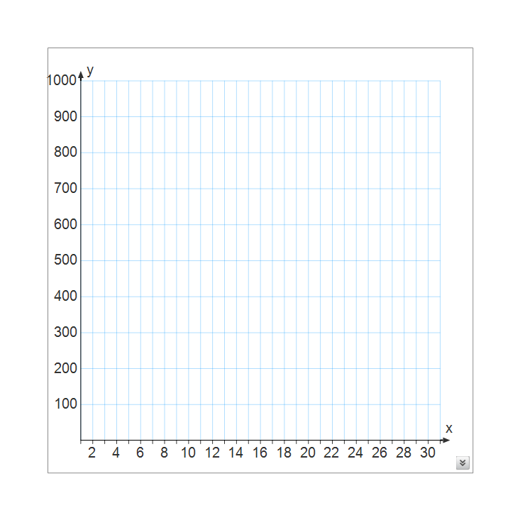 **Percent Circle: Daily Variable Graph**



**Arrays:**

|  |  |  |  |  |  |  |  |  |  |  |  |  |  |  |  |  |  |  |  |  |  |  |  |  |  |  |  |  |  |
| --- | --- | --- | --- | --- | --- | --- | --- | --- | --- | --- | --- | --- | --- | --- | --- | --- | --- | --- | --- | --- | --- | --- | --- | --- | --- | --- | --- | --- | --- |
| **2** | **3** | **4** | **5** | **6** | **7** | **8** | **9** | **10** | **11** | **12** | **13** | **14** | **15** | **16** | **17** | **18** | **19** | **10** | **21** | **22** | **23** | **24** | **25** | **26** | **27** | **28** | **29** | **30** | **31** |
|  |  |  |  |  |  |  |  |  |  |  |  |  |  |  |  |  |  |  |  |  |  |  |  |  |  |  |  |  |  |

**Daily Data**

Degrees Fahrenheit

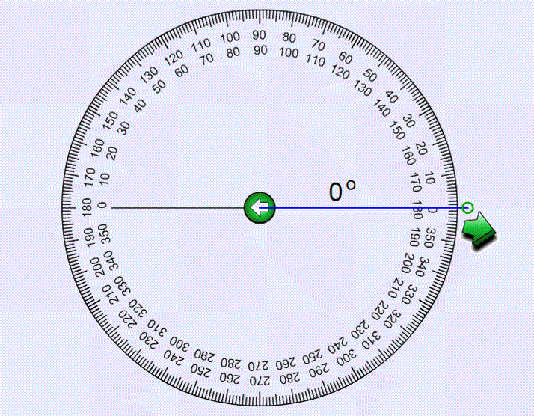 **Daily Circle**