Bellringer: Find the following formulas on your yellow reference sheet:

- Regular Prism: SA = _____________
- Right CircularCylinder: SA = __________
- Pyramid: SA = ____________________
- Right Circular Cone = _______________
- Triangle: A = __________________
- Parallelogram: A = ____________
- Circle: A = ________________
- Circle: C = ________________

LESSON

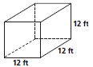
Identify the Solid___________
Write the formula for SA____________
B = ____
C/P = ____
h/l = ____
Substitute values into formula___________
SA = ___________

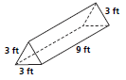
Identify the Solid___________
Write the formula for SA____________
B = ____
C/P = ____
h/l = ____
Substitute values into formula___________
SA = ___________

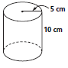

Identify the Solid___________
Write the formula for SA____________
B = ____
C/P = ____
h/l = ____
Substitute values into formula___________
SA = ___________

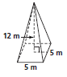
Identify the Solid___________
Write the formula for SA____________
B = ____
C/P = ____
h/l = ____
Substitute values into formula___________
SA = ___________

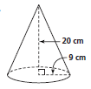
Identify the Solid___________
Write the formula for SA____________
B = ____
C/P = ____
h/l = ____
Substitute values into formula___________
SA = ___________
Classwork

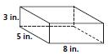
Identify the Solid___________
Write the formula for SA____________
B = ____
C/P = ____
h/l = ____
Substitute values into formula___________
SA = ___________

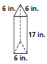
Identify the Solid___________
Write the formula for SA____________
B = ____
C/P = ____
h/l = ____
Substitute values into formula___________
SA = ___________

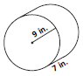
Identify the Solid___________
Write the formula for SA____________
B = ____
C/P = ____
h/l = ____
Substitute values into formula___________
SA = ___________

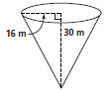
Identify the Solid___________
Write the formula for SA____________
B = ____
C/P = ____
h/l = ____
Substitute values into formula___________
SA = ___________

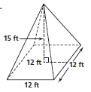
Identify the Solid___________
Write the formula for SA____________
B = ____
C/P = ____
h/l = ____
Substitute values into formula___________
SA = ___________

