Geometry
Notes 12.2 Translations
Definitions:
1.) translation-is a ___________________ that maps all points of a figure the same distance in the same direction. It changes the position of the figure with no effect on shape or size.
2.) vector- an ordered pair that is in angle brackets. We use vectors to describe ____________________. The first coordinate tells you how far ____________ or ____________ to move. The second coordinate tells how far _____________ or _____________ to move the figure.
3.) composition- is a transformation that is a _______________ of two or more transformations.
Examples of translations:
Example #1:
If point Q has coordinates (-2,3), what is the image of Q under each translation?
A.) <-5,1> B.) <0, -2> C.) <3,-3>

Example #2:
Given the coordinates are P(3,1), Q(-1,0), W(-2,3) and U(-4,3) Find the vector that describes the translation:
A.) P$→$Q B.) W$→$U C.) P$→$U

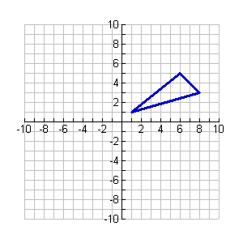
Example #3:
A(6,5), B(1,1), C(8,3)
We will translate ΔABC by the vector <-2, -3>. This means we will move each point left 2 and down 3. We will label the new triangle to be ΔA’B’C’. Where the image of <A is <A’, the image of <B is <B’ and the image of <C is <C’.
Fill in the coordinates of A’, B’ and C’ below:
A’ (_____,_____), B’ (_____,_____), C’ (_____,_____)
C
B
A
Fill in the congruences below:
$$\overline{AB} ≅\overline{ }$$
$$\overline{AC} ≅\overline{ }$$
$$\overline{BC} ≅\overline{ }$$

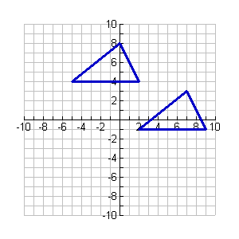
Example #4:
Write a rule to describe the translation.
Z
Y’
Y
Z’
X’
X

Example #5:
Find a single translation that has the same effect as each composition.
A.) <2,3> followed by <1.8,-3> B.) <1,2> followed by <-3,5>

