Scavenger Hunt: Systems of Equations
Answer Sheet
1. | 2.
3. | 4.
5. | 6.
7. | 8.
9. | 10.
11. | 12.

Card A
No Solution
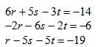

Card J
( 1, -1, 5)
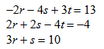

Card E
(5, -5, 1)
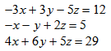

Card G
(-4, 5, 3)
9x – 7y = -16
-3x + y = -8

Card C
(6, 10)
20x – 5y = -10
10x + 6y = -22

Card L
(-1, -2)
-x + 3y = 16
8x – 6y = -2

Card B
(5 , 7)
3x – 7y = -18
9x – 9y = -18

Card I
(1, 3)
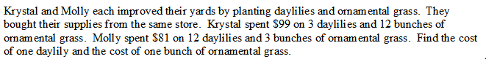

Card K
$5 and $7
Card F
$9 and $10
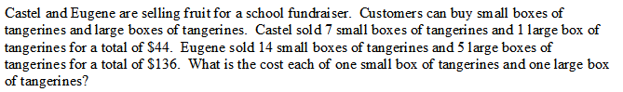

Card D
$4 and $16
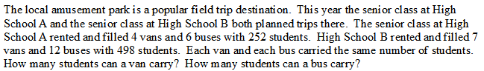

Card H
6 and 38
