Geometry
Notes 12.7 Dilations
Definitions:
1.) dilations-A transformation where the preimage and image are _______________ but not ______________________. It is not __________________. It is an ___________________ or ___________________ of the size of an image.
2.) enlargement- to make an image ____________________. Scale factor will be __________ than 1.
3.) reduction- to make an image ________________. Scale factor will be ________ than 1.
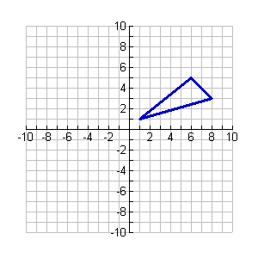
Examples of dilations:
Example #1:
A(6,5), B(1,1), C(8,3)
Use matrices to fine the image under the dilation centered at the origin with a scale factor of .5
C
B
A

Fill in the coordinates of A’, B’ and C’ below:
A’ (_____,_____), B’ (_____,_____), C’ (_____,_____)

Example #2:
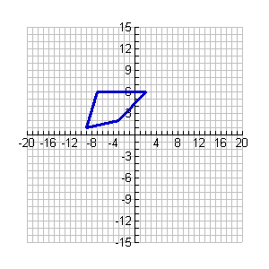

M(-7,6), X(2,6), Z(-3,2), Y(-9,1)
Z
Y
X
M
Use matrices to fine the image under the dilation centered at the origin with a scale factor of 1.5.

Fill in the coordinates for the new image.
M’ (_____,_____), X’ (_____,_____),
Z’ (_____,_____), Y’ (_____,_____)

Example #3:
Use scalar multiplication to find the image of ΔPQR got s dilation with center (0,0) and the given scale factor.
P Q R
x-coordinate 3 2 -4
y-coorinate -1 6 9
Scale factor 1/3

