Geometry Name________________

Equations of Lines Review

1. The slope of is  and the slope of  is . What can be concluded about  and ?

2. The midpoint of has coordinates (-1,1). Point A has coordinates (-5,3). What is the y-coordinate coordinate of point C?

3. Which is the equation of a line parallel to 

a. 

b. 

c. 

d. 

4. Find the distance from (-2, -8) to (-9, 1).

5. Find the perimeter of  with vertices *A*(–8, –4), *B*(–4, –4), and *C*(–8, –1).



|  |
| --- |
|  |

[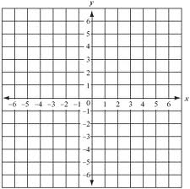](http://www.google.com/imgres?hl=en&sa=X&rlz=1T4TSNO_enUS457US459&biw=1366&bih=589&tbm=isch&prmd=imvns&tbnid=aQvd1lwNAOnpOM:&imgrefurl=http://www.mpsaz.org/field/staff/jgramirez/math/&docid=dnOGAhAnP87emM&imgurl=http://www.mpsaz.org/jefferson/staff/tepeterson/math/math_glossary/images/coordinate.plane.2.gif&w=327&h=326&ei=zls4T8yiEcHmggeOr9nnBQ&zoom=1)6. Graph *y* = *x* +1.

|  |  |  |  |
| --- | --- | --- | --- |
|  |  |  |  |
|  |  |  |  |

[](http://www.google.com/imgres?hl=en&sa=X&rlz=1T4TSNO_enUS457US459&biw=1366&bih=589&tbm=isch&prmd=imvns&tbnid=aQvd1lwNAOnpOM:&imgrefurl=http://www.mpsaz.org/field/staff/jgramirez/math/&docid=dnOGAhAnP87emM&imgurl=http://www.mpsaz.org/jefferson/staff/tepeterson/math/math_glossary/images/coordinate.plane.2.gif&w=327&h=326&ei=zls4T8yiEcHmggeOr9nnBQ&zoom=1)7. Graph .

|  |  |  |  |
| --- | --- | --- | --- |
|  |  |  |  |
|  |  |  |  |

8. Write an equation in point-slope form of the line through point *J*(5, –2) with slope 3.

|  |  |  |  |
| --- | --- | --- | --- |
|  |  |  |  |
|  |  |  |  |

9. Write an equation in point-slope form of the line through points (3, 8) and (5, 2). Use (3, 8) as the point (*x*1, *y*1).

|  |  |  |  |
| --- | --- | --- | --- |
|  |  |  |  |
|  |  |  |  |

10. Write an equation for the horizontal line that contains point *E*(10, –2).

11. Write an equation in slope-intercept form of the line through points *S*(3, 6) and *T*(4, 4).

|  |  |  |  |
| --- | --- | --- | --- |
|  |  |  |  |

12. Is the line through points *P*(–1, –9) and *Q*(3, –5) parallel to the line through points *R*(–4, –1) and *S*(–5, –4)? Explain.

|  |  |
| --- | --- |
|  |  |
|  |  |

13. Which two lines are parallel?

|  |  |
| --- | --- |
| I.  II.  III. | 1. I and II 2. I and III 3. II and III 4. No two lines are parallel. |

|  |  |  |
| --- | --- | --- |
|  |  |  |
|  |  |  |

14. Write an equation for the line parallel to *y* = 4*x* + 2 that contains *P*(5 –5) in point-slope form.

|  |  |  |  |
| --- | --- | --- | --- |
|  |  |  |  |
|  |  |  |  |

15. Write an equation for the line perpendicular to *y* = –4*x* –9 that contains (–7, 3) in point-slope form.

16. Give the slope-intercept form of the equation of the line that is perpendicular to –5*x* + 7*y* = 11 and contains

*P*(–1, –10).

|  |  |  |  |
| --- | --- | --- | --- |
|  |  |  |  |
|  |  |  |  |

17. Each unit on the map represents 5 miles. What is the actual distance from Oceanfront to Seaside?



|  |  |
| --- | --- |
|  |  |
|  |  |  |  |

18. Find the midpoint of **

|  |  |  |  |  |  |  |  |
| --- | --- | --- | --- | --- | --- | --- | --- |
|  |  |  |  |  |  |  |  |

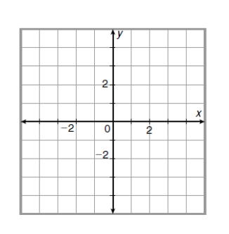19. Draw and classify the polygon with vertices E(-4, 1), F(-2, 3), and G(-2, -4). Find the area and perimeter of the polygon.

20. Find the coordinates of the midpoint of the segment whose endpoints are *H*(8,6) and *K*(12, 10).