Investigation: Midsegments of Triangles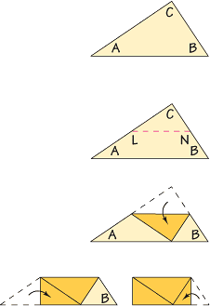

Draw, label, and cut out a large scalene triangle. Label the vertices *A*, *B*, and *C*.

* Fold *A* onto *C* to find the midpoint of segment A C.
* Do the same for segment B C.
* Label the midpoints *L* and *N*, then draw segment L N.
* Fold each triangle on segment L N.
* Fold *A* to *C*. Fold *B* to *C*.

1. How does *LN* compare to *AB*? Explain.
2. Make a conjecture about how the segment joining the midpoints of two sides of a triangle is related to the third side of the triangle.

A midsegment is ___________________________________________________________________

The midsegment is:

1. _______________________________________________________________________________

2. _______________________________________________________________________________

List the three pairs of parallel segments:

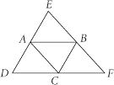













Homework: Midsegments







Find the value of each variable:



