**Area and Perimeter from a Graph**

|  |  |  |  |
| --- | --- | --- | --- |
| Figure | Name | Area | Perimeter |
| http://www.pearsonsuccessnet.com/snpapp/iText/products/0-13-037878-X/Ch01/01-07/images/Ch1_Sec07_im002.gif |  |  |  |
| http://www.pearsonsuccessnet.com/snpapp/iText/products/0-13-037878-X/Ch01/01-07/images/Ch1_Sec07_im002.gif |  |  |  |
| http://www.pearsonsuccessnet.com/snpapp/iText/products/0-13-037878-X/Ch01/01-07/images/Ch1_Sec07_im002.gif |  |  |  |
| Image shows a parallelogram with height h and width b. |  |  |  |
| Image of a triangle, with base length b, and height h. |  |  |  |
| picure of a trapezoid showing base 1, base 2, and h, the height. |  |  |  |
| Rhombus or a Kite  showing diagonals d sub 1 and d sub 2. |  |  |  |

Area Perimeter

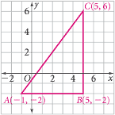

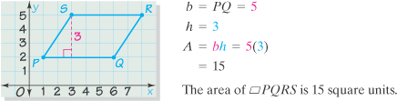

Area Perimeter











