**5** Topic Review

**For Items 1–2, find the value of each  
expression.**

**1.**

**2.**

**3.** Simplify

**a.**

**4.** Multiply

**5.** Which of the following is  
equivalent to

**A**

**B**

**C**

**D**

**6.** The graph of has been  
translated to the left 2 units and  
up 1 unit. What is the equation of  
the translated graph?

**A**

**B**

**C**

**D**

**7.** The function *a* has domain *x* ≥ −2  
and range *y* ≤ 1. What are the  
domain and range of *a*−1?

Domain:

Range:

**8.** Graph the function

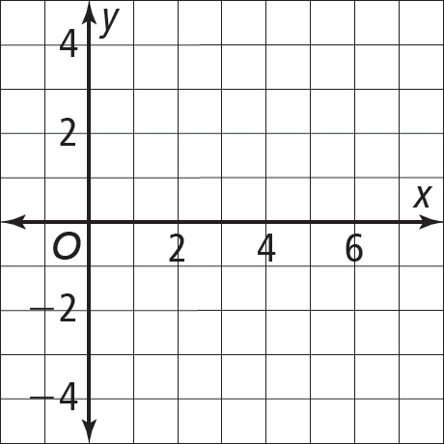

**9.** Which of the following are real  
numbers? Select all that apply.

**A** **C**



**B** **D**



**10.** The volume of a cube is 2.8 m3. Find the length of its edge to the nearest tenth of a meter.

**11.** Multiply

HINT: Use a calculator

**12.** Which of the following is a  
decreasing function?

**A**

**B**



**C**



**D**



**13.** Let and *g*(*x*) = What  
is the domain of *f* ◦ *g*?



**A** x > 7 **C** x > 7

**B** x < 7 **D** x < 7

**14.** If what is an equation  
for ?

**A**

**B**

**C**

**D**

**15.** Evaluate the expression when

**16.** Some values of *f*(*x*) are given in the  
table. Find the value of *f*−1(3).

|  |  |  |  |
| --- | --- | --- | --- |
| ***x*** | 2 | 3 | -3 |
| ***f*(*x*)** | 3 | 1 | 5 |

**17.** A cylindrical pipe is 25 ft long  
and has a volume of 900 ft3. Find  
its approximate diameter to the  
nearest hundredth of a foot. V = Bh

**A** 3.39 ft **C** 6.77 ft

**B** 6 ft **D** 12 ft

**18.** Solve



**19**.

**20.** A store increases all its prices by  
20% and then offers a $50 discount  
on all purchase prices. Let *x*represent the price in dollars. Let  
*f*(*x*) = 1.20*x* represent the increase  
and *g*(*x*) = *x* − 50 represent the  
discount. Which function can the  
store manager use to find the final  
purchase prices?

**A** *f* + *g* **C**



**B** *f* × *g* **D**

**21.** Solve



**A** 0 **C** 1.25

**B** 1 **D** 2

**22.** The volume of a sphere is  
and the radius is  
increasing at 5 mm per second. The  
function *r*(*t*) = 5*t* gives the radius  
at time *t* seconds. Which function  
gives the volume at time *t*?



**A**



**B**



**C** (*r* + *V*)(*t*)

**D** (*V* ∙ *r*)(*t*)

**23.** Solve the equation



All values of x |