Given the following points, do the following:

1. Graph and connect each point
2. Calculate the slope
3. 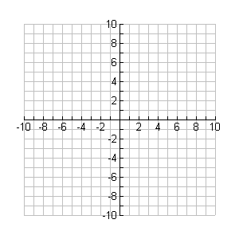Calculate the midpoint
4. Calculate the distance (round to the nearest tenth).

1. (10, 7) and (10,5)



2. (-1, 1) and (1, 5)

3. (-5, -7) and (-8, -1)

4. (0, 7) and (-5, 3)

If a triangle has the following 2 side measures, what are the possible values of the third side of this triangle? Show your work.

5. 7 and 11

6. 13 and 18

7. 20 and 24

8. 3 and 3

Find the missing angle measures

9.

2x°

2x°

x°

x°

116

x

y

123

62

10.

The following triangles are isosceles.

11. Find the value of x.

80°

x°

12. The equal side os the isosceles triangle have a measurement of and . The third side measures . Find the perimeter of this triangle. Show your work.