Geometry Name___________________________

Common Assessment 4 Review 1 Date___________ Period__________

1. Point D is in the interior of  What is the 

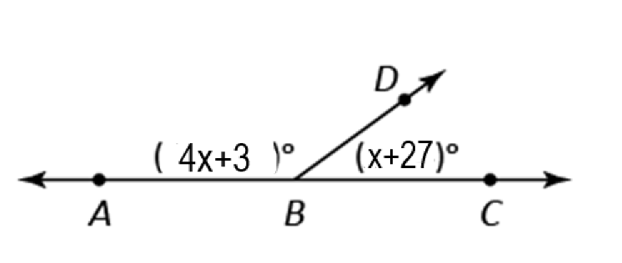

= o

1. Which angle is congruent to  Select all that apply. (**Choose 2 answers**!!)

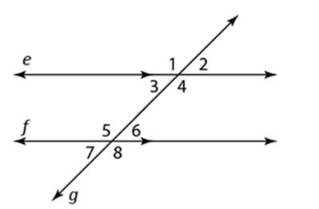

* A. 
* B. 
* C. 
* D. 

1. Use the quadrilateral KLMN.

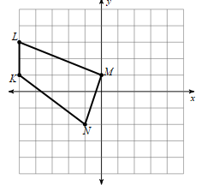

What are the coordinates of the image ?

K’=

L’=

M’=

N’=

1. What is a rule for the translation of  to  Select all that apply. **(Choose 2 answers!!)**

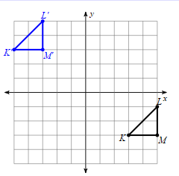

* A. 
* B. 
* C. 8 units right, 6 units down
* D. 8 units down, 6 units right

1. 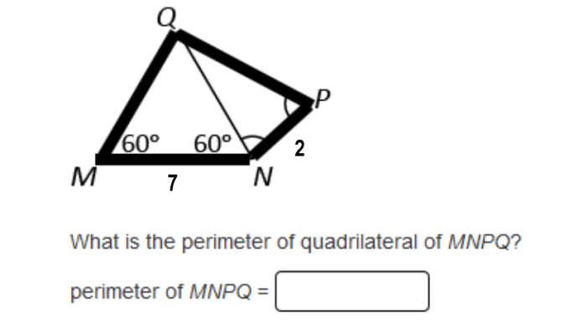
2. Refer to the diagram shown.

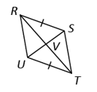

If  and bisect each other, which theorem(s) can be used to show that  Select all that apply. **Choose 2 answers!!**

* A. AAS
* B. SSS
* C. ASA
* D. SAS

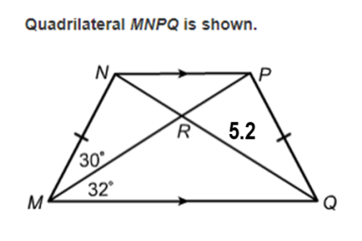



If MP= 9.8, what is RN?

* A. 5.2
* B. 9.8
* C. 4.6
* D. not enough information

1. 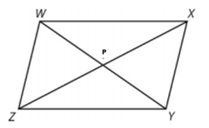 The diagonal of parallelogram WXYZ intersect at P. Which statements must be true? Select all that apply. (Choose 3 answers!!)

* A. 
* B. 
* C. 
* D. 

1. How do the angles and side lengths of the preimage relate to the corresponding angles and side lengths of the image of a dilation with a scale factor not equal to 1?

* A. The angles are congruent and the side lengths are proportional.
* B. The angles are proportional and the side lengths are proportional.
* C. The angles are proportional and the side lengths are congruent.
* D. The angles are congruent and the side lengths are congruent.

1. The point A has coordinates A(3,5). What are the coordinates of A’ for the dilation 



1. The image of a figure that undergoes one or more rigid motions and a dilation is always

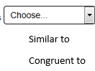its preimage.

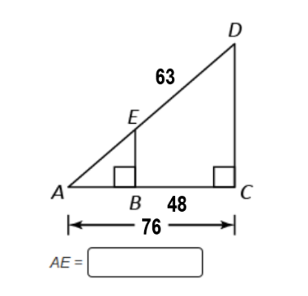

1. Given  and  What is  Find AB first.
2. What is the scale factor of the dilation shown?

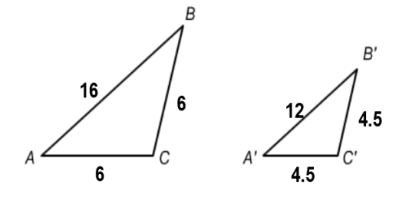

* A. 
* B. 
* C. 
* D. 

1. Which conclusion does the diagram support?

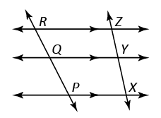

* A. 
* B. 
* C. 
* D. 

1. What is AB?

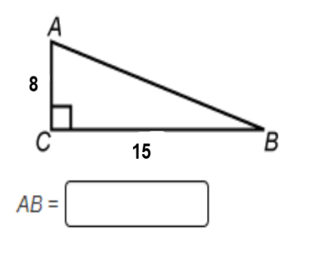

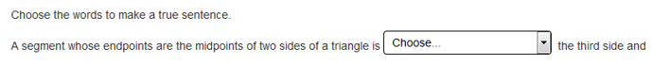

Half the length of

Twice the length of

The same length as



Perpendicular

Adjacent

Parallel

1. 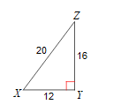 Which is the cosine ratio of 

* A. 
* B. 
* C. 
* D. 

1. Which value is equal to  Select all that apply. **(Choose 2 answers!!)**

* **A.** 
* **B.** 
* **C.** 
* **D.** 
* **E.** 
* **F.** 

1. What is to the nearest tenth?

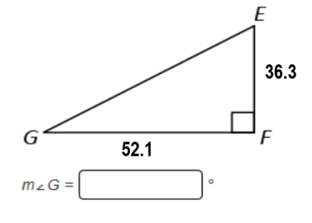

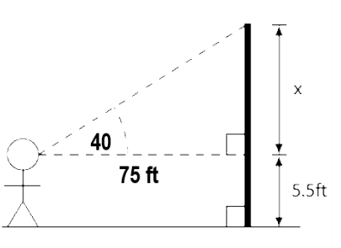



The angle of elevation from a viewer to the top of a flagpole is 40 degrees. The viewer is 75 feet away and the viewer’s eyes are 5.5 feet from the ground. How high is the pole to the nearest tenth of a foot?

First find x and then find the height of the pole.

