Investigation: Transformation Graphing on the TI-nspire
Let’s use our graphing calculator to examine some graphs we have already discussed. Turn your calculator on. To pull up the graph screen you can do one of the following:
Press » until the graph screen comes up OR
press B from the home screen (the screen you get when you turn the calculator on).
Press / G over and over again. What happens? ________________________________________________
f1(x) = is where we will type our equations. Let’s practice by graphing the some of the equations from our homework last night.
y = x² can be graphed by typing X q · in the f1(x) line.
Once you type something in the f(1) line the next graph line will come up. What is that graph label? __________
To graph y = 2^{x}, we will type 2 l X · in f2(x) = .

We are going to investigate how graphs change with operations on x. But before we do, let’s clear our current graphs. To do this, press delete three times quickly and choose yes.

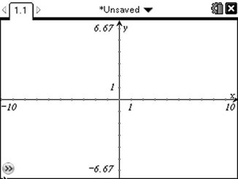
Now let’s see what some basic changes do to the graph:
A. Graph the following and sketch your graph:
f1(x) = x
f2(x) = x + 4
f3(x) = x – 3

What do you notice?
How does the graph change?
Let’s summarize:

f(x) + c
f(x) – c

This is called a ________________________________ __________________________.
Describe in words how you would graph the line y = x+ 99 using the graph of y = x.
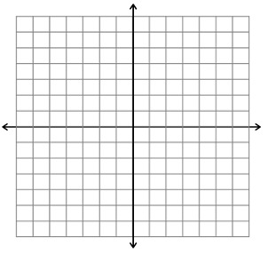
Sketch the following graphs precisely without your calculator:
y = x – 1
y = x + 3.5

B. Clear your current graphs.
Graph the following and sketch your graphs:
f1(x) = x²
f2(x) = (x – 6)²
f3(x) = (x + 2)²
What do you notice?
How does the graph change?
Let’s summarize:

f(x + c)
f(x – c)

This is called a ________________________________ __________________________.

Describe in words how to graph y = (x – 12)² using y = x².
Sketch these graphs without your calculator:
y = (x + 3)²
y = ( x – 6)²

C. Clear your graphs. Let’s see what a coefficient in front of the graph does.
Graph the following and see what happens. Sketch your graphs:
(To graph absolute value, press t and use arrows and · to select | |
f1(x) = |x|
f2(x) = 3|x|
f3(x) = $\frac{1}{4}$ |x|
f4(x) = - |x|

What do you notice?

How does the graph change?
Let’s summarize:
whole number in front _________________________________________________________________
fraction in front ______________________________________________________________________
negative in front _____________________________________________________________________

Describe in words how we would graph y = - 4 |x|. Hint: two changes are involved.

Sketch these graphs without your calculator:
y = (1/2)|x|
y = 5|x|
y = -(1/3)|x|

Time to put the calculator away! Let’s use what we discovered to accurately graph the following:
1. y = (x + 5)² – 1 2. y = 2|x – 2| + 3
family _____________ family ____________
__________________ _________________
__________________ _________________

3. y = -2(x – 3)² + 1 4. y = - |x + 4| + 3
family _____________ family ____________
__________________ _________________
__________________ _________________
__________________

Write the equation of each graph:
5. 6. 7. 8.

   

