Algebra 1 Topic 2 Warm Up Name:_____________________________
Date | Ex: 1 | Ex: 2 | Ex: 3 | Ex: 4
2-0 | What is the slope of the line:  y = $-\frac{1}{2} x-5$ | Find the slope of the line from the given points:  (2, 3) and (-4, 1) | 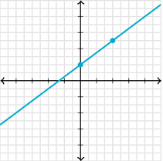  Find the slope of the line from the graph: | Find the equation of the line from the given table:  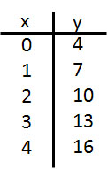
2-2 | Write the equation of the line in point-slope form that passes through the point (2, -3) and has a slope of -5. | Write the equation of the line in point-slope form that passes through (2, -1) and (-3, 3). | Sketch the graph of  $$y+ 2 =\frac{1}{2}( x-3)$$  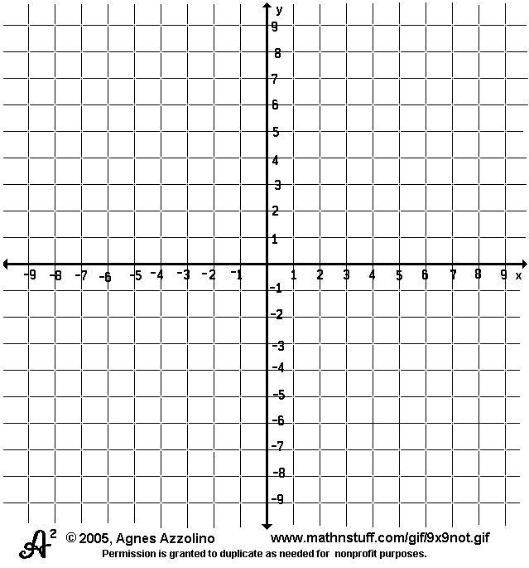 | Write the equation of the line from the graph in point-slope form.  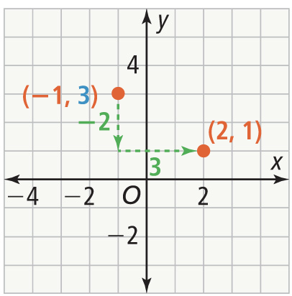
2-1 | Sketch the graph of the equation.  y = $-\frac{3}{4} x-5$ | Write the equation of the line in slope-intercept form. | Rewrite the point-slope equation in slope intercept form.$$y - 5 =10( x-3)$$ | Write the equation of the line in slope intercept that passes through the points  (5, 4) and (-1, 6).
2-3 | Write the equation that expresses the following scenario: Hannah will spend $150 on music tickets. Reserved seats cost $25 and general admission tickets cost $10. | Find the x and y intercepts and then sketch the graph of  4x + 5y = 10 | Sketch the graph of the equation 3y = -18 | Sketch the graph of the equation 4x = 12
2-4 | What are the characteristics of parallel lines?  What are the characteristics of perpendicular lines? | Write the equation of the line in point-slope form that passes through the point (-3, 5) and is parallel to y = $-\frac{2}{3} x$. | Write the equation of the line in slope-intercept form that passes through the point (4, 5) and is perpendicular to y = 2$x-3$. | Are the equations of the lines parallel, perpendicular, or neither? Explain.  y = 2x + 6 and y = $\frac{1}{2}x+3$.
ACT | What is the slope of the line given the equation 3x = 30 – 5y | In the standard xy coordinate plane, what is the slope of the line that is perpendicular to  5y – 12x = 35 | A boat company has a fixed monthly cost of $1500, and $50 per boat. They sell boats for $75 a piece. How many boats must be sold each month to break even. | The length in meters of a rectangular fence is 4 more than twice its width. Write an equation in terms of length of the rectangular fence.

