8 Topic 1 Review Scavenger Hunt

Choose a card. Answer the question on the right side of the card. Find the answer to your question on the left hand side of another card. Answer the question on that card and continue until you have answered all questions. Record your work below:

Card Number | Work Space | Answer

$$\frac{1}{4^{12}}$$ | - Farrah’s math grade average is $82.\overline{7}$%. How can you represent the repeating decimal $0.\overline{7 }$ as a fraction?
3.427 x 10⁴ | 2. Classify each number as rational or irrational.  $\sqrt{8}$ 6.1010010001…… 4.03 $5.\overline{98}$ $\sqrt{81}$  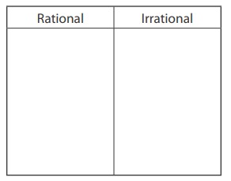
5 | - How would you classify the number 64?  𝖠. perfect square  𝖡. perfect cube  𝖢. both a perfect square and a perfect cube  𝖣. neither a perfect square nor a perfect cube
4.36 x 10⁵ | - Ron asked 27 classmates whether they prefer granola bars over muffins. He used a calculator to compare the number of classmates who said yes to the total number he surveyed. The calculator showed the result as 0.44444444.  Part A Write this number as a fraction.  Part B How many students prefer granola bars over muffins?
38 | - What is the side length, s, of the square?  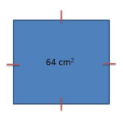
30 | 6. Solve the equation x² = 21.
Rational Irrational  $$\sqrt{81}$$ 4.03 $$5.\overline{98}$$ 6.1010010001…. $$\sqrt{8}$$ | 7. A cube-shaped box has a volume of 125 cubic inches. If the box is packed full of cubes with edge lengths of 1 inch, how many cubes can fit along one side of the box?
12 | 8. Evaluate the expression for x = 3 and y = 2.  4x² + 2x⁰ ·(y – 1)
$$\frac{7}{9}$$ | 9. Draw lines to connect each expression on the left with an equivalent expression on the right.  $$x^{3}$$ $$x^{9}$$  $$x^{2}∙x^{2}∙x^{2}$$ $$\frac{1}{x^{-3}}$$  $${\left(x^{3}\right)}^{3}$$ $$x^{2}$$  $$x^{7}÷ x^{5}$$ $$x^{6}$$
$$x= ±\sqrt{21}$$ | 10. Express the number 0.0000436 in scientific notation.
8 cm | 11. Rewrite 4⁻¹² using a positive exponent.
C | 12. In 1902, the yearly attendance at a major league baseball park was 2.4 × 10⁵ people. One hundred years later, the yearly attendance was 7.2 × 10⁶ fans. How many times greater was the attendance in 2002 than in 1902?
$$x^{3}$$ $$x^{9}$$  $$x^{2}∙x^{2}∙x^{2}$$ $$\frac{1}{x^{-3}}$$  $${\left(x^{3}\right)}^{3}$$ $$x^{2}$$  $$x^{7}÷ x^{5}$$ $$x^{6}$$ | 13. Find (3.4 × 10⁴) + (2.7 × 10⁶). Express your answer in scientific notation.

