Rally Coach: Graphing Linear Functions
Names (A)_________________________ (B)_________________________ (C) ____________________________

Problem 1:
Graph y = 2x – 3

Person A

Determine the initial value of the function.

Person C check and initial _____
Person B

Find the slope of the function.

Person A check and initial _____
Person C

Use the initial value and slope to graph the function.

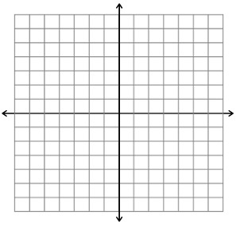

Person B check and initial _____

Names (A)_________________________ (B)_________________________ (C) ____________________________

Problem 2:
Graph y = -3x + 1

Person A

Determine the initial value of the function.

Person C check and initial _____
Person B

Find the slope of the function.

Person A check and initial _____
Person C

Use the initial value and slope to graph the function.

Person B check and initial _____

Names (A)_________________________ (B)_________________________ (C) ____________________________

Problem 3:
Graph y = $\frac{3}{4}$x – 3

Person A

Determine the initial value of the function.

Person C check and initial _____
Person B

Find the slope of the function.

Person A check and initial _____
Person C

Use the initial value and slope to graph the function.

Person B check and initial _____

Names (A)_________________________ (B)_________________________ (C) ____________________________

Problem 4:
Graph y = $\frac{-5}{3}x+4$

Person A

Determine the initial value of the function.

Person C check and initial _____
Person B

Find the slope of the function.

Person A check and initial _____
Person C

Use the initial value and slope to graph the function.

Person B check and initial _____

Names (A)_________________________ (B)_________________________ (C) ____________________________

Problem 5:
Graph y = $\frac{1}{5}x-2$

Person A

Determine the initial value of the function.

Person C check and initial _____
Person B

Find the slope of the function.

Person A check and initial _____
Person C

Use the initial value and slope to graph the function.

Person B check and initial _____

