Advanced Geometry Name:
11.2 Notes Supplement Date:

Volume of Prisms and Cylinders

Example 1: Cavalieri’s Principle

How are the volumes of the two different stacks of index cards related?
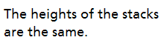
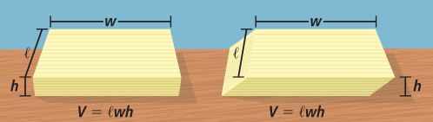
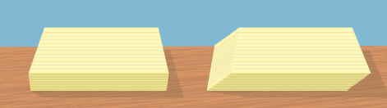
Height:

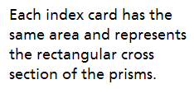
Area:

Right Prism
A prism such that all the sides are perpendicular to the bases.
Oblique Prism
A prism such that some or all of the lateral faces are nonrectangular.
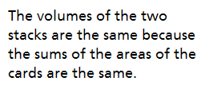
Volume:

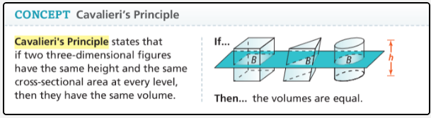

Example 2: Volumes of Prisms and Cylinders
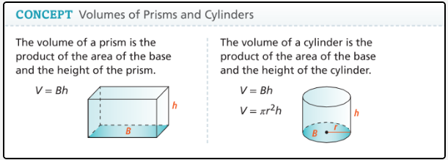

- Lonzell needs to store 20 ft³ of firewood. Could he use the storage rack shown?
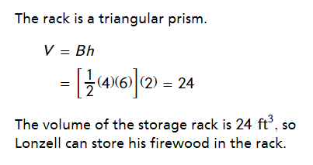
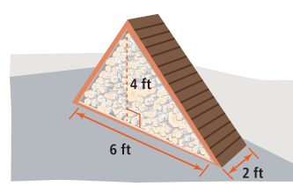

How would the volume of the storage shed change
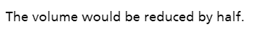
if the length of the triangular base is reduced by half?

- Keisha is deciding between the two canisters shown. Which canister holds more? What is the volume of the larger canister?
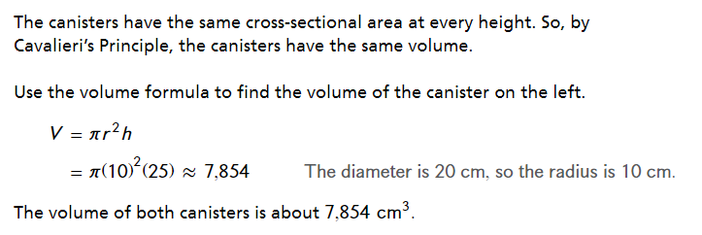
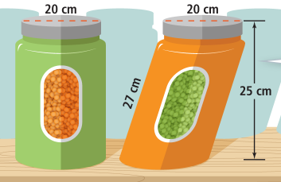

How would the volume of the canisters change
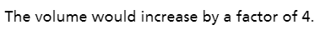
if the diameter is doubled?

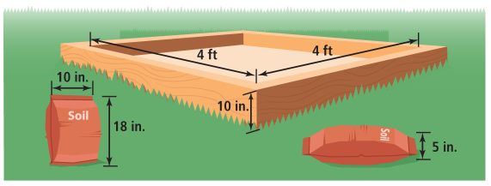
- Marta is repurposing a sandbox as a garden and is buying the soil from her school’s fundraiser. Estimate the number of bags she should buy.

