Notes: The Geometry of Parabolas
Try this:
Draw a line and a point on a piece of patty paper.
Fold the point over to the line.
Move the point over to another part of the line and fold again.
Repeat at least 20 times.
What do you notice?
Let’s use coordinate geometry to find the equation:
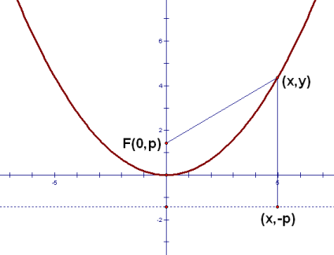
_____________________

_____________________

_____________________

We can find the equation of a parabola given the vertex as the origin and either the focus or directrix:
Vertex at origin, focus (0, 1/4) vertex at orgin , focus at (0, -1/80)

vertex at origin, directrix y = -1/8 vertex at origin, directrix y = 1

What if the origin is not the vertex?
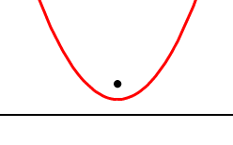

Find the equation of the parabola given the following information:
Vertex ( -7, -9) Focus (-7, -145/16) Vertex (-10, -4) Focus (-10, -271/68)

Vertex (0, 10) Directrix y = 121/12 Vertex (-2,-7) Directrix y = -27/4

Challenge: Focus (-8, 25/24) Directrix y = 23/24

Homework:
Find the equation of each parabola. Check your answer with the answer bank at the bottom of the page.

1. Vertex at origin, Focus (0, -1/16)
2. Vertex at origin, Focus (0, -1/8)
3. Vertex at origin, Directrix y = 1/4
4. Vertex at origin, Directrix y = -1/4
5. Vertex (-9,8), Focus (-9, 65/8)
6. Vertex (1,-10), Focus (1, -39/4)
7. Vertex (-6,2), Directrix y = 9/4
8. Vertex (1,-2), Directrix y = -143/72

Answer Bank

y = -18(x – 1)² – 2
y = -4x²
y = -2x²
y = -(x + 6)² + 2
y = -x²
y = x²
y = (x – 1)² – 10
y = 2(x + 9)² + 8

