Topic 4 Review
Solving Systems of Equations and Inequalities
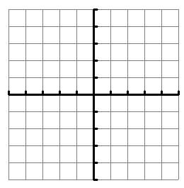
Work the problems out on paper. Then, enter your final answer in Easy Bridge.
- Solve the system by graphing. Write the solution as an ordered pair. (x, y)
Hint: Graph both lines and see where they intersect.
$${y=\frac{1}{3}x+2 \atop y=-x-2}$$

- Choose the correct label for the solution in each system of equations from the drop-down menu. (Choices are: one solution, no solution or infinitely many solutions)
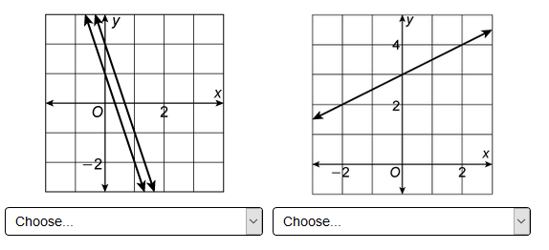
- Use substitution to determine the solution of the system of equations.
$${y=-2x-7 \atop 2y-x=1}$$
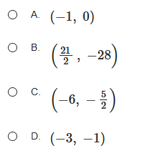
- Choose the correct words from the drop-down menue to make a true statement about the system of equations. (Choices are one solution, no solution or infinitely many solutions)
Use substitution method!
$${y=\frac{1}{3}x+2 \atop -x+3y=6}$$

- Find the solution to the system of equations. Write the solution as an ordered pair. (x, y)
Use elimination method. Figure out what you need to multiply by to eliminate the y. Then solve.
$${5x-4y=-10 \atop 3x+2y=16}$$

- Which sysyem has the same solution as the system of equation shown?
What is the result of the first step when using the elimination method? You don’t need to solve.
$${8x+3y=5 \atop 4x+2y=3}$$
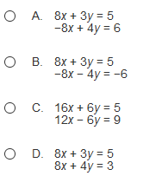
- Which inquality does the graph represent?
- What is the y-intercept?
- What is the slope?
- Is the inequality > or <?
- Should we include the “or equal to” sign?
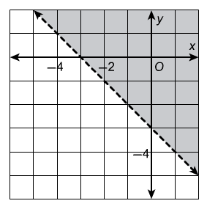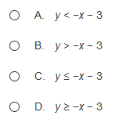

- Choose the graph that matches the system of inequalities.
First take each equation and solve for y. Then graph.

Focus on the inequality of each line.
Should it be a solid or dashed line?
Should it be shaded above or below?
$${-x+y≤-1 \atop x+2y≥4}$$
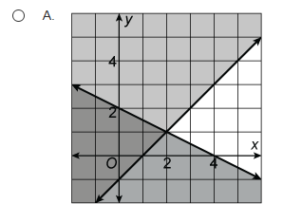 | 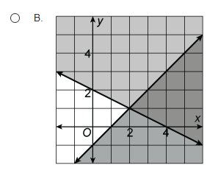
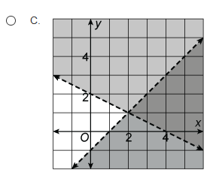 | 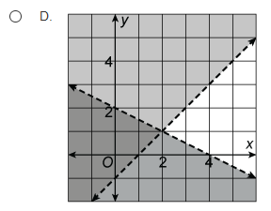

- At a movie theater, the price of 2 adult tickets and 4 child tickets is $48. The price of 5 adult tickets and 2 child tickets is $64. What is the ticket price for one adult and for one child? (Must include $ sign in answer before the number)
Let a = adult ticket price and c = child ticket price.
Set up 2 equations.
Solve using the elimination method.

Teacher Notes (Do not give this page to students)
Question On Review | Where the Question Came From
1 | Topic 4 Assessment Form A #1
2 | 4-1 Lesson Quiz #3
3 | 4-2 Lesson Quiz #1
4 | Topic 4 Assessment Form A #6
5 | Topic 4 Assessment Form A #8
6 | Topic 4 Assessment Form A #9
7 | Topic 4 Assessment Form A #13
8 | Topic 4 Assessment Form A #16
9 | Topic 4 Assessment Form A #18

