Lesson 1.4 Literal Equations and Formulas
Interactive Student Edition

Model & Discuss
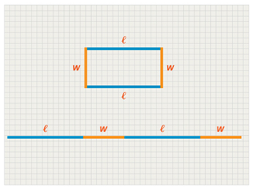
Nora drew a nonsquare rectangle. Then she drew the length of each side from end to end to make a line segment to represent the perimeter.
- Write an equation that represents the perimeter of the model shown.
- Drag to rearrange the order of the sides so you can represent the perimeter with a different equation. Is this equation equivalent to your first equation?
- Use Structure How many different ways can you express the relationship in parts A and B? Are any of them more useful than others?
HABITS OF MIND
Construct Arguments What mathematical argument supports your response in part C?

LESSON ESSENTIAL QUESTION
How is rewriting literal equations useful when solving problems?
Example 1 CONCEPTUAL UNDERSTANDING Rewrite Literal Equations
Janet wants to calculate the time it takes to earn a certain amount of interest on a principal amount in an investment with simple interest. What equation can she use?
Try It!
- What equation can Janet use to calculate the principal amount?
Example 2 Use Literal Equations to Solve Problems
In a half hour, Sarah is meeting her friends at the lake, 6 mi from her house. At what average speed must she ride her bike to get there on time?
Try It!
- Sarah is going to the store 2.5 mi away. She has only 15 min to get there before they close. At what average speed must she ride to get to the store before they close?

HABITS OF MIND
Use Structure How is solving equations with numbers the same as solving equations with only variables?

Example 3 Rewrite a Formula
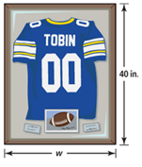
A worker at a framing store is making a rectangular frame. He knows that the perimeter of the frame is 144 in. and the length is 40 in. How can he determine the width of the frame?
Try It!
- Write the formula for the area of a triangle, $A=\frac{1}{2}bh$, in terms of h. Find the height of a triangle when $A=18$ in.² and $b=9$in.

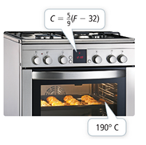
Example 4 APPLICATION Apply Formulas
According to Teo’s bread recipe, he should bake the bread at 190°C for 30 minutes. His oven measures the temperature in °F. To what temperature in °F should he set his oven?
Try It!
- The high temperature on a given winter day is 5°F. What is the temperature in °C?
HABITS OF MIND
Reason How are the variables in the temperature conversion formula related?

