Unit 2 EOC Assessment: Quadratic Functions
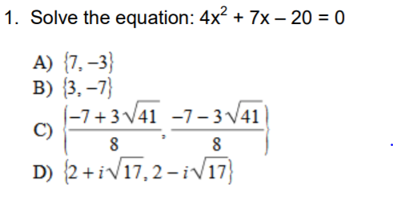
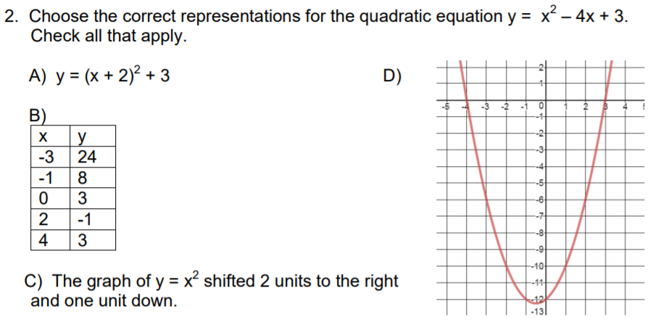
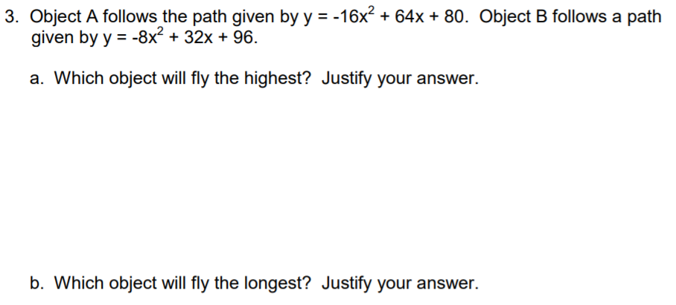

Unit 2 EOC Assessment supporting problems (for use in class lessons)
2-1 Vertex form of a quadratic equation
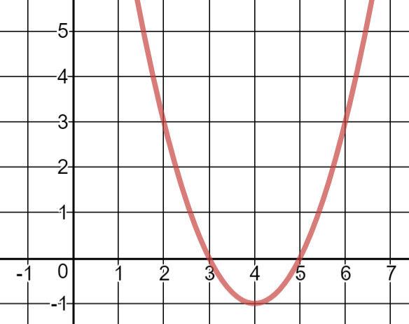
Identify the vertex and zeros of the quadratic function.

Describe the transformation of the quadratic function.

2-2 Standard form of a quadratic equation
Find the vertex of the equation y = x² + 6x – 3.

The graph of the function f(x) = -8x² + 640x – 200 shows the profit a company earns selling headphones. What is the maximum profit a company can expect to earn?

2-3 Factored form of a quadratic equation
Find the zeros of the equation x² – 7x = 18.

Dave hits a ball into the air. The function h(t) = -16t² + 32t + 48 gives the height of the ball in feet. When will the ball hit the ground?

2-4 Complex numbers and operations
Which quadratic function(s) have no real solutions? Select all that apply.
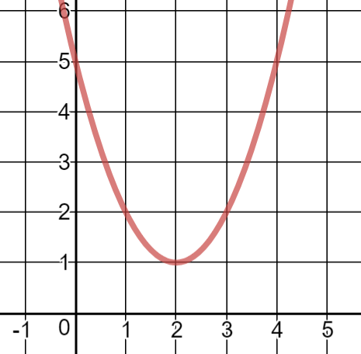 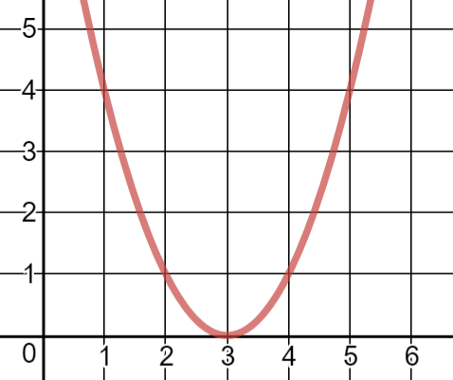 y = x² + 4x + 5 y = x² – 3x – 5

2-5 Completing the square
Solve the quadratic equation by completing the square: -24 = x² + 14x

2-6 The quadratic formula
Solve the quadratic equation using the quadratic formula: 0 = x² – 18x + 64.
Janine launches a model helicopter. The height of the helicopter in feet is given by the equation h(t) = -16t² + 64t + 190. Find the vertex of the parabolic path of the helicopter. What does the vertex describe in real world context?
Find the zeros of the parabolic path of the helicopter. What would be the purpose of finding the zeros in the real world?

Review
Consider the quadratic equation y = x² – 6x + 8.
- Graph the equation and find the vertex and zeros.
- Solve the equation by the method of your choice.
- Compare and contrast the original equation with the equations y = (x – 3)² – 1 and y = (x – 4)(x – 2). How are they related? Why would it be helpful to write equations in these forms?

